***Introduction***

New York is the [most populous city](https://en.wikipedia.org/wiki/List_of_United_States_cities_by_population) in the [United States](https://en.wikipedia.org/wiki/United_States) . New York is also the [most densely populated](https://en.wikipedia.org/wiki/List_of_United_States_cities_by_population_density) major city in the United States. New York City has been described as the [cultural](https://en.wikipedia.org/wiki/Culture_of_New_York_City), financial, and media capital of the world, significantly influencing commerce, entertainment, research, technology, education, politics, tourism, art, fashion, and sports . New York is home residents born outside the United States  the largest foreign-born population of any city in the world .There are many languages are spoken in New York .This makes this city extremely diverse .With its diverse culture there are many food culture / restaurants available in City . As part of this project we will try to navigate different area of New York and determine which area has best Indian restaurants.

***Data***

For this project we will use Data source : <https://cocl.us/new_york_dataset> to collect boroughs and Neighborhoods information. We will use Foursquare API to collect restaurants *information , rating .*

***Approach***

We will first collect New York City data .

Using Foursquare API we will find venue for each area.

Filter out data only with Indian restaurants and find rating ,tips etc information .

We will use rating and sort the data .

***Questions that can be asked using the above mentioned datasets***

* What is best location in New York City for Indian Cuisine ?
* Which areas have potential Indian Resturant Market ?
* Which all areas lack Indian Resturants ?
* Which is the best place to stay if I prefer Indian Cuisine ?

***Analysis***

We will import the required libraries for python.

* pandas and numpy for handling data.
* request module for using FourSquare API.
* geopy to get co-ordinates of City of New York.

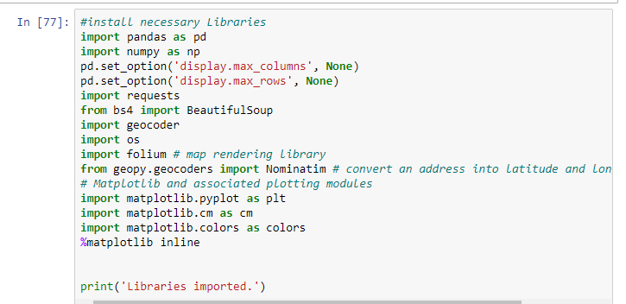

Now we define a function to get the geocodes i.e latitude and longitude of a given location using geopy.

**def** geo_location(address):

*# get geo location of address*

geolocator = Nominatim(user_agent="ny_explorer")

location = geolocator.geocode(address)

latitude = location.latitude

longitude = location.longitude

**return** latitude,longitude

We define a function to intract with FourSquare API and get top 100 venues within a radius of 1000 metres for a given latitude and longitude. Below function will return us the venue id , venue name and category.

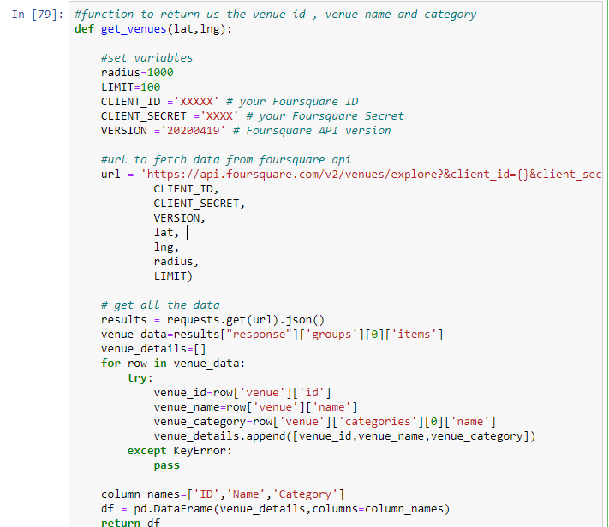

Now we will define a function to get venue details like like count , rating , tip counts for a given venue id. This will be used for ranking.

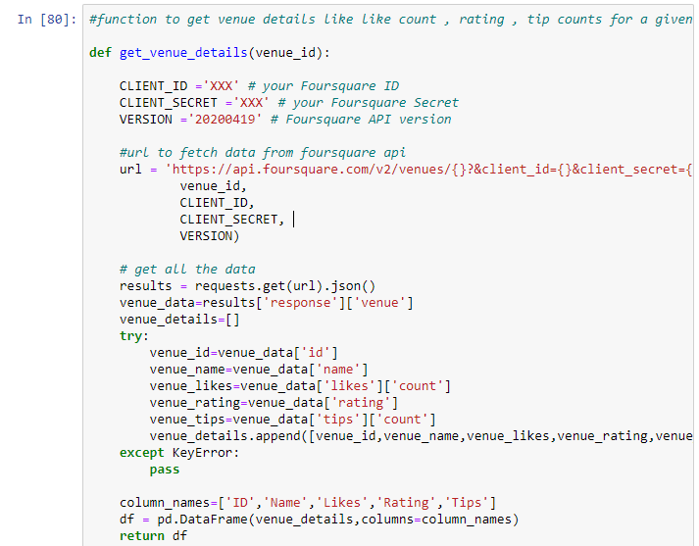

Now we define a funtion to get the new york city data such as Boroughs, Neighborhoods along with their latitude and longitude.

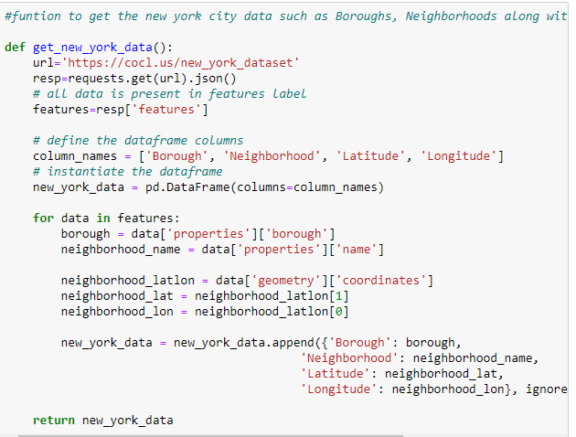

We will call the above funtion to get the new york city data.

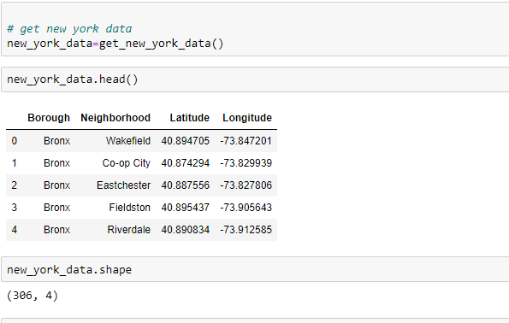

So there are total of 306 different Neighborhoods in New York

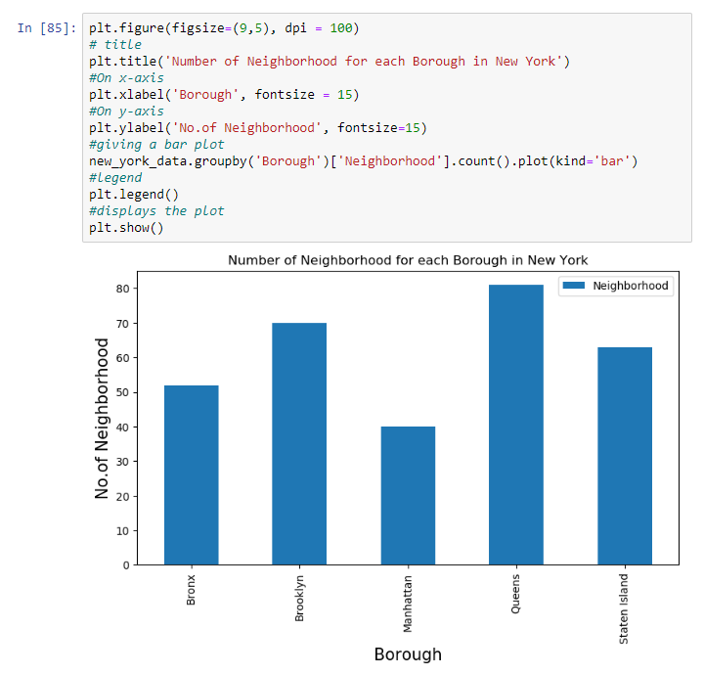

We see that Queens has highest number of neighborhoods

Now we will collect Indian restaurants for each Neighborhood

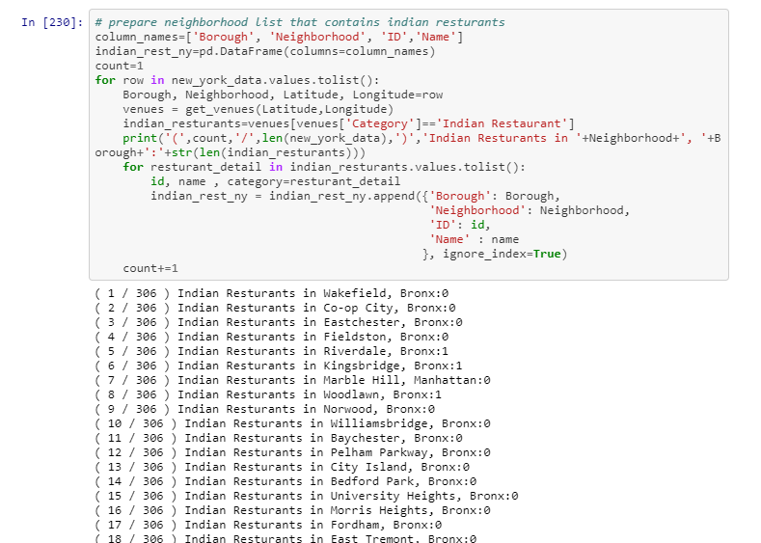

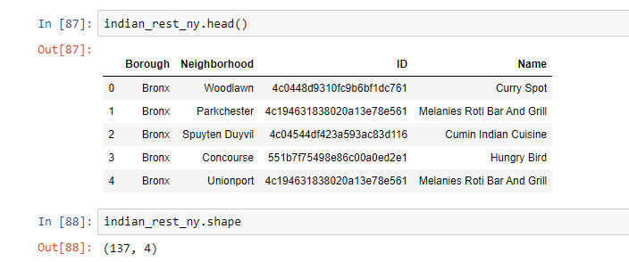

We got 137 Indian Resturants across New York City

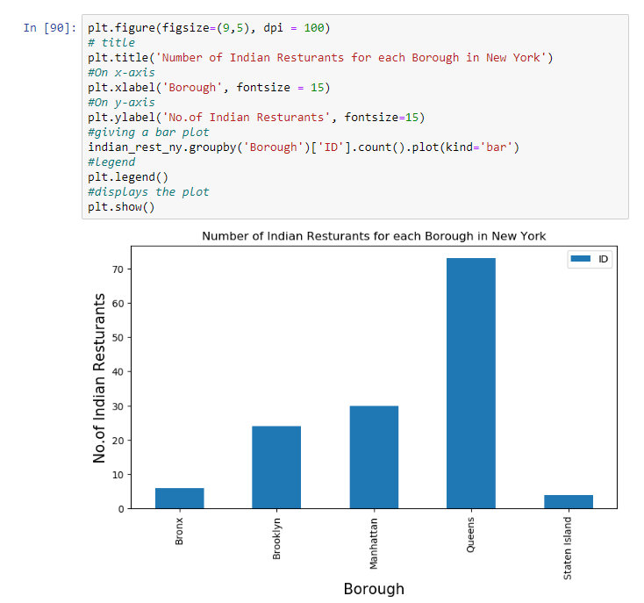

We see that Queens has the largest number of indian restaurants.

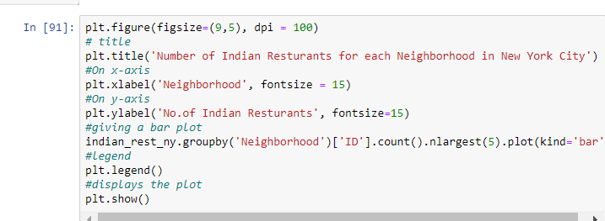

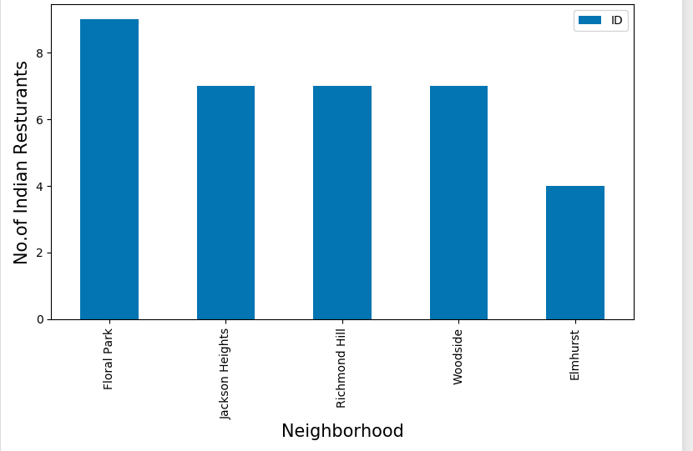

So Floral Park in Queens has the highest number of Indian Resturants

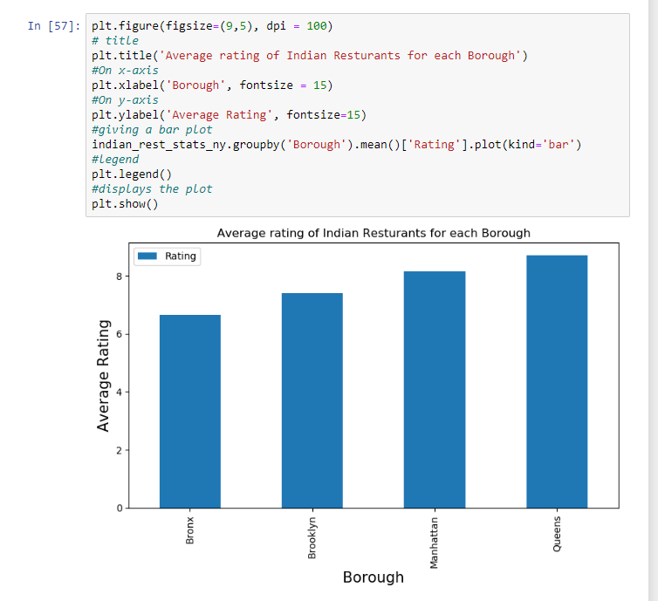

**Conclusion**

* Astoria(Queens), Blissville(Queens), Civic Center(Manhattan) are some of the best neighborhoods for indian cuisine.
* Manhattan have potential Indian Resturant Market/
* Staten Island ranks last in average rating of Indian Resturants.
* Manhattan is the best place to stay if you prefer Indian Cuisine.